* **Synopsis for Car Rental System Project in C++:**

**Car Rental System**

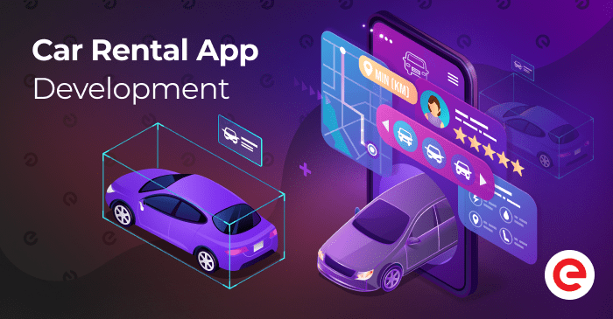

**Introduction:**

The **Car Rental System Project in C++** is a simulation of a vehicle rental system designed to mimic real-world operations such as selecting a vehicle, renting it for a specified duration, and calculating costs based on various factors like vehicle type and rental duration. This project applies the core principles of Object-Oriented Programming (OOP) to develop a digital model that demonstrates real-world interactions between customers and rental services.

In today's digital age, simulations are crucial for prototyping and testing business processes before implementing them on a larger scale. This software project showcases the importance of simulations in creating applications like a car rental system using C++, simulating the entire process from vehicle selection, rental time tracking, to cost calculation.

The user interacts with a console-based application, making it user-friendly, while the program manages the internal complexity. The system will encapsulate key features such as vehicle selection, rental cost calculation, and time management. The application also includes error handling to manage invalid inputs, making it robust and adaptable to various scenarios.

The concepts of inheritance, encapsulation, and polymorphism have been brought into this project. This project provides a complete example of how C++ can be applied to develop simulations for real-world business operations. It offers practical experience in programming, system modeling, and algorithm development.

**Objective:**

* **Simulate Core Car Rental Operations:**  
  Design a program that will mimic the primary operations of a car rental system, including selecting a car, renting it for a period, and calculating costs. It will be developed using C++.
* **Implement Object-Oriented Programming (OOP):**  
  To model a car rental system with various vehicle types using OOP concepts like classes, inheritance, and polymorphism.
* **User Interaction and Input Handling:**  
  Create a console-based application where the user can input parameters such as vehicle type, rental duration, and deal with possible errors through input validation.
* **Simulate Time-Based Operations:**  
  Simulate rental periods, giving users a real-time-like experience by utilizing timer or sleep functions in C++.
* **Demonstrate Systematic Process Flow:**  
  Design a structured process flow that illustrates the stages of car rental - vehicle selection, rental period, and cost calculation based on time and car type.
* **Error Detection and Handling:**  
  Implement error-handling mechanisms in case of invalid user inputs, ensuring smooth execution of the program.
* **Promote Software Simulation for Business Operations:**  
  Present examples of how software simulations can be used to test and optimize business processes like car rentals before physical implementation.

**Tools and Technologies:**

* **Object-Oriented Programming (OOP):** Used for structuring the car rental system’s features.
* **Conditional Statements (if-else):** For making decisions based on user inputs (e.g., vehicle selection, rental duration).
* **Loops:** To simulate time-based rental processes.
* **Functions and Operations:** To conduct specific operations such as calculating rental costs and managing vehicle availability.
* **Development Environment:** Code:Blocks, Visual Studio, or any other C++ IDE.

**Methodology:**

* **Car Rental:** A class representing the general car rental system, including attributes like vehicle type, rental duration, and methods for calculating rental costs and availability.
* **Vehicle Selection:** Controls the selection process, allowing the user to choose different vehicle types such as economy, sedan, or SUV.
* **User Interface:** A command-line interface that allows users to input their preferences and track the rental process.

**Algorithms Will Be Used to Manage:**

* Rental cost calculation based on vehicle type and duration.
* Time management for the rental period.
* Input validation and error handling for invalid inputs**.**

**Expected Outcome:**

At the end of this project, the simulation should successfully demonstrate the basic functionality of a car rental system through a console interface. It will also demonstrate an understanding of object-oriented design, proper handling of user input, and time-based operations.

**Conclusion:**

The project will provide insights into object-oriented programming in C++ and demonstrate how complex systems like a car rental service can be modeled and simulated. The lessons learned from this project can be applied to more complex real-world business simulations and operations.

Name :- Vedant Nagawade

PRN :- 2124UCSM1048

Department :- Cybersecurity

Car rental application development - blog cover